**ASSIGNMENT 5.3**

**PROBLEM STATEMENT :**

Write a MapReduce program to view the total sales for each product for every Company corresponding to each size. Make sure that all records for a single company goes to a single reducer and inside every reducer, keys must be sorted in descending order of the size. You may write a custom WritableComparable for this purpose. "

**Screenshot for Driver class1:**

The required program is as follows for the driver class:

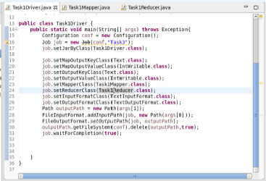

**Screenshot for Mapper class1:**

The program for the first mapper class is represented as the follows :

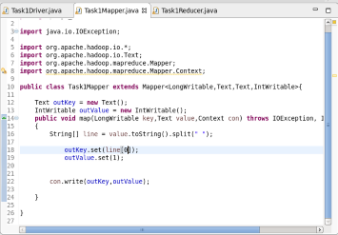

**Reducer class1:**

**The first reducer class is depicted as below:**

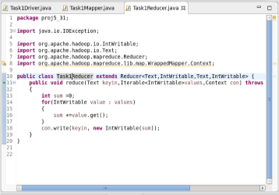

**Output:**

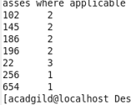

**Driver class2:**

The required program is as follows for the second driver class:

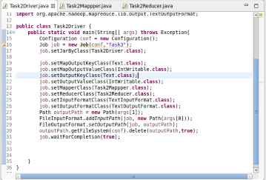

**Mapper 2:**

The program for the first mapper class is represented as the follows :

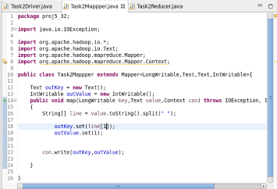

**Reducer 2:**

**The second reducer class is depicted as below:**

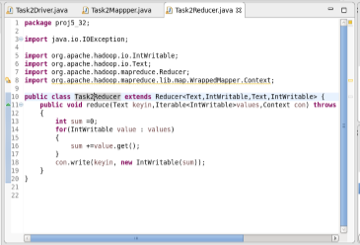

**Output2:**

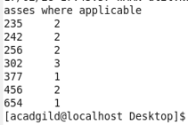

**Thus the required outputs are obtained as represented above as per the problem statement respectively.**